OBJECTIVE:

Coronavirus disease (COVID-19) is an infectious disease caused by the SARS-CoV-2 virus.

REQUIREMENTS:

* Build an application that people can access the application, get the accurate count of covid and certificates
* The applications should have login, dashboard page, certificate page and result page
* The applications should be designed as in people and have only read access.
* This application should have a provision to maintain a database for vaccinated people with 1st and 2nd dosage, non vaccinated people, active covid people, affected people and cured people
* Also an integrated platform required for government and people
* Government admin module to include options for adding /modifying/removing the existing data with an update.

APPLICATION ASSUMPTIONS:

1. The login page should be the first page rendered when the application loads.

2. Login should be done using their aadhar card and password given by the government to aadhar given by government

3. In dashboard page, the application contains a map. When we select a state/country it will show us the count of the people who got affected in active state and cured ones.

4. In certificate page, people can download their certificate.

5. To navigate to the admin side , you can store a user type as admin in the database with a username and password as admin

6. Use admin/admin as the username and password to navigate to the admin dashboard where they will have access to add/modify the data

7. Helpline number should be available in login page I.e Near by centres /hospitals that are available.

Coronavirus disease (COVID-19):

It is an infections disease caused by the SARS-COV-2 virus. Most people infected with the virus will experience mild to moderate respiratory illness and recover without requiring special treatment. However, some will become seriously ill and require medical attention.

COVID-19 system:

Fever or chills, cough, shortness of breath or difficulty breathing, and fatigue.

When covid -19 caused:

Infection with severe acute respiratory syndrome coronavirus 2, or SARS-CO-V-2, causes coronavirus disease 2019(COVID-19). The first transmission to humans was in Wuhan, China. Since the virus that causes covid-19 spreads easily among people.

How it is caused:

When people with covid-19 breathe out cough, they expel tiny droplets that contain the virus. These droplets can enter the mouth or nose of someone without the virus, causing an infection to occur.

Data has shown that the covid-19 virus spreads mainly from person to person among those in close contact. The disease is most contagious when a person’s symptoms are at their peak. However it is possible for someone without symptoms to spread the virus .A new study suggests that 10% of infections are from people exhibiting no symptoms .

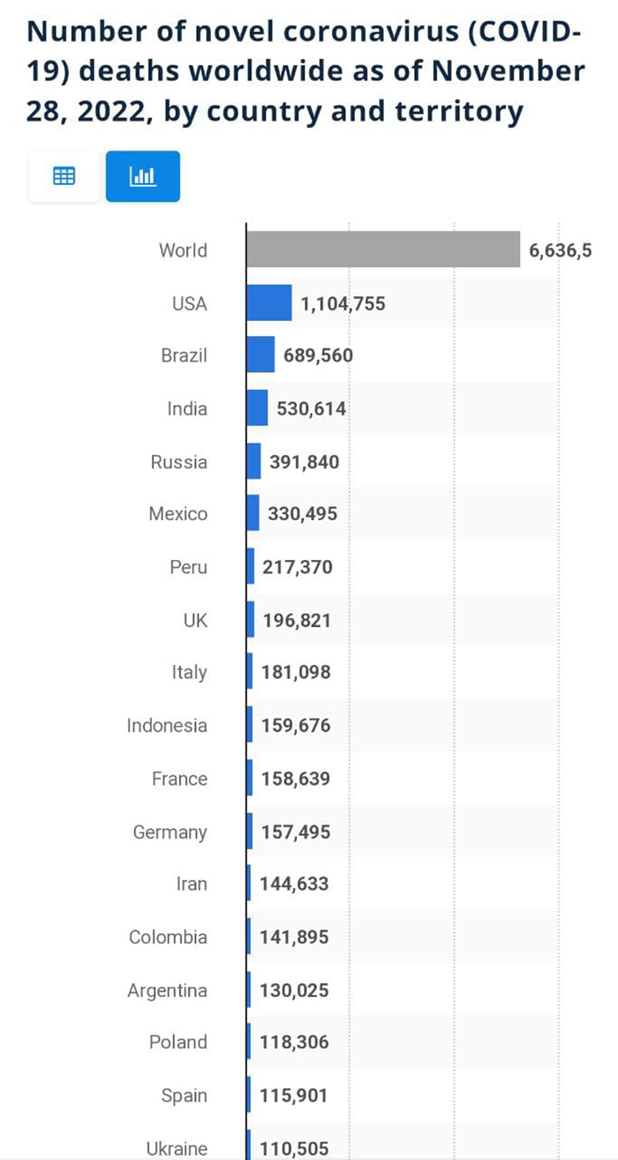

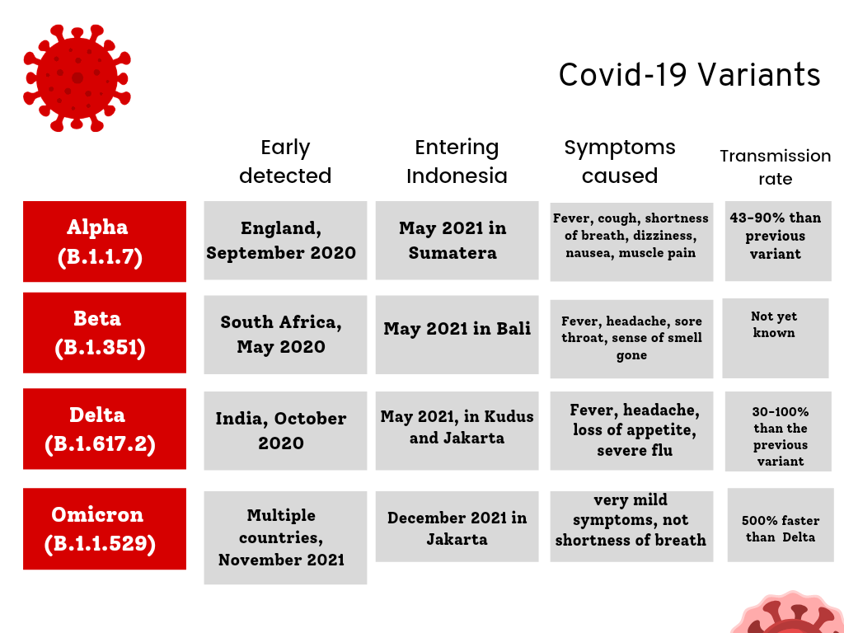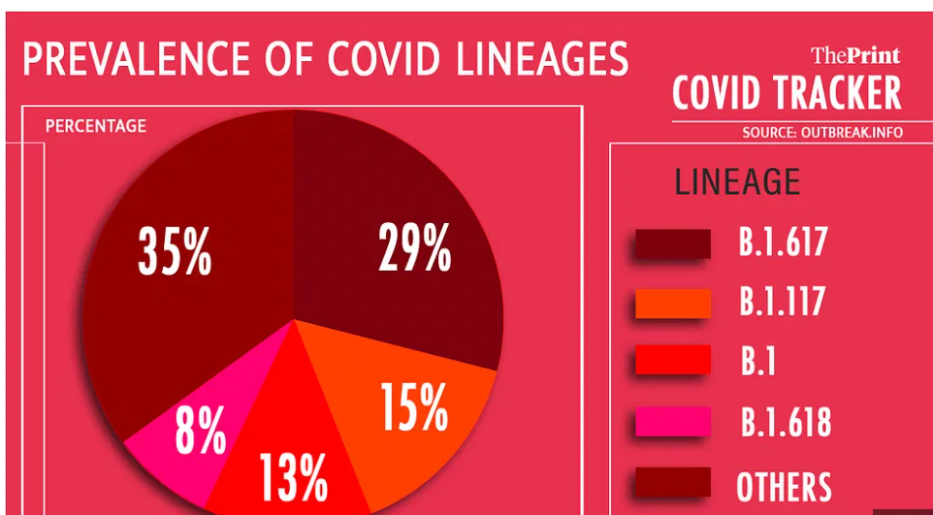

PRECAUTION OF COVID 19

Get vaccinated as soon as it’s turn and follow local guidance on vaccination.

Keep physical distance of at least 1 metre from others, even if they don’t appear to be sick.

Avoid crowds and close contact.

Wear a properly fitted mask when physical distancing is not possible and in poorly ventilated settings.

Clean your hands frequently with alcohol-based hand rub or soap and water

Cover your mouth and nose with a bent elbow or tissue when you cough or sneeze. Dispose of used tissues immediately and clean hands regularly

If you develop symptoms or test positive for COVID – 19, self-isolate until you recover

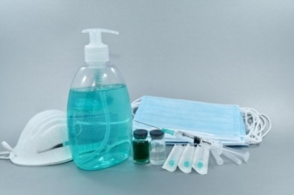

COVAXIN VS COVISHIELD – WHAT IS THE DIFFERENCE

Compared to the Covaxin vaccination for Corona, the COVID vaccine Covishield has more side effects.

The side effects such as headache, vomiting, nausea, and fever are also more intense.

In very rare cases of 1 in 100,000 people, Covishield can also lead to blood clots.

There is also a difference between when you can get the second dose.For COVID vaccine Covishield, you can get the second dose for 8-12 weeks after your first dose.

The gap is longer for Covishield vs Covaxin

|  |  |  |  |  |
| --- | --- | --- | --- | --- |
| **STATE** | **CONFIRMED CASES** | **ACTIVE CASES** | **CURED/**  **DISCHARGED** | **DEATH** |
| ANDAMAN AND NICOBAR | 10157 | 42 | 9986 | 129 |
| ANDHARA PRADESH | 2321379 | 755 | 2305893 | 14731 |
| ARUNACHAL PRADESH | 64518 | 4 | 64218 | 296 |
| ASSAM | 724788 | 395 | 716405 | 7988 |
| BIHAR | 832581 | 934 | 819388 | 12259 |
| CHANDIGARH | 93785 | 568 | 92052 | 1165 |
| CHHATTISGARH | 1154179 | 861 | 1139282 | 14036 |
| DADRA NAGAR HAVELI AND DAMAN AND DIU | 11474 | 14 | 11456 | 4 |
| DELHI | 1934009 | 4325 | 1903423 | 26261 |
| GOA | 248540 | 982 | 243720 | 3838 |
| GUJARAT | 12231483 | 2914 | 1217623 | 10946 |
| HARYANA | 1015501 | 2655 | 1002222 | 10624 |
| HIMACHAL PRADESH | 286061 | 507 | 281413 | 4141 |
| JAMMU AND KASHMIR | 455006 | 447 | 449803 | 4756 |
| JHARKHAND | 435858 | 284 | 430254 | 5320 |
| KARANATAKA | 3968365 | 5707 | 3922541 | 40117 |
| KERALA | 6634722 | 28860 | 6535869 | 69993 |
| LADAKH | 28411 | 78 | 28105 | 228 |
| LAKSHADWEEP | 11408 | 3 | 11353 | 52 |
| MADHYA PRADESH | 1044243 | 490 | 1033012 | 10741 |
| MAHARASHTRA | 7972474 | 25735 | 7798817 | 147922 |
| MANIPUR | 137266 | 18 | 135128 | 2120 |
| MEGHALAYA | 93947 | 65 | 92288 | 1594 |
| MIZORAM | 229048 | 261 | 228084 | 703 |
| NAGALAND | 35507 | 2 | 34744 | 761 |
| ODISHA | 1289602 | 627 | 1279849 | 9126 |
| PUDUCHERRY | 166438 | 304 | 164172 | 1962 |
| PUNJAB | 762755 | 1079 | 743903 | 17773 |
| RAJASTHAN | 1288328 | 939 | 1277825 | 9564 |
| SIKKIM | 39224 | 26 | 38744 | 454 |
| TAMIL NADU | 3473116 | 10033 | 3425057 | 38026 |
| TELANGANA | 800476 | 4421 | 791944 | 4111 |
| TRIPURA | 100901 | 7 | 99971 | 923 |
| UTTRA PRRADESH | 2090050 | 3541 | 2062971 | 23538 |
| UTTARAKHAND | 438663 | 787 | 430180 | 7696 |
| WEST BENGAL | 2027901 | 5885 | 2000798 | 21218 |
| INDIA | 43452164 | 104555 | 42822493 | 525116 |

PROJECT DONE BY:

1.ALLANSIA FEBI-IT-A 111722203007

2.HARSHA-IT-A-111722203032

3.EZHIL ARASI-IT-A-111722203024